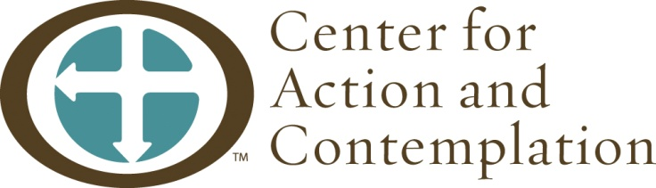

Resources and Information for Planned Giving

Our Vision: Amidst a time of planetary change and disruption, we envision a recovery of our deep connection to each other and our world, led by Christian and other spiritual movements that are freeing leaders and communities to overcome dehumanizing systems of oppression and cooperate in the transforming work of Love.

Thank you for your consideration in partnering with the CAC in the work to awaken a more loving world. Your support will allow us to continue advancing our mission for years to come. By including us in your Planned Giving, you would be a core partner in making this all possible. CAC is not sustained by any large institution, foundation, or corporation; we are funded by thousands of people around the world who give freely because they have been impacted by this work.

Thank you for your generosity and partnership. We sincerely appreciate it.

A note on our Fundraising approach:

Driven by our founding values, we believe in the principle of sufficiency and spirit-led generativity. This means, we will never pressure or “push” for your support past what is freely and joyfully given. Our desire and goal is that you live as deeply as possible into your sacred soul task with your time, energy, and resources. If that includes partnering with the CAC to help fuel our mission and vision, we honor your support and will passionately work to put it to good use. But if being true to your sacred soul task means being a generous steward of your resources on a different path, we honor your journey and the uniqueness of your gift in this world, wherever they may be applied.

The CAC is just one part in the great body of Christ, and we believe that there is enough to go around.

If you are interested in including CAC in your planned giving, there are several options:

Make a bequest in your will

The easiest and most direct way to make a charitable gift is by an outright bequest in your will. Making an outright bequest requires only a short paragraph in your will that names the charitable beneficiary and states the percentage (or specific amount) of your gift. In order to identify the CAC please use the following information:

Center for Action and Contemplation, Inc.
PO Box 12464
Albuquerque, NM 87195
505-242-9588
501c3 Tax identification number 85-0354965

A residuary bequest can also be a good method for charitable giving. This approach names the percentage of your charitable gift from the reminder of your assets once debts, obligations, taxes or other bequests have been paid. This makes sure that your family or primary obligations are taken care of and then supports the charity with the percentage thereafter.

Make us the beneficiary of a life insurance policy

This method only requires that you name the CAC as the beneficiary of your life insurance policy. Life insurance proceeds paid to a charity are not subject to income and estate taxes, probate costs, and other expenses and transfer of assets from an insurance contract is incontestable.

Make us the beneficiary of an IRA or retirement plan
If you have funds in an IRA or employer-sponsored retirement plan, you can name the CAC as a beneficiary.

Making a donation via a direct Stock or Electronic Funds Transfer (EFT):

If you would like to contribute stock or make an EFT please contact CAC’s Director of Development and Partnerships who can give you the specific account details you need to make this possible.
Ben Keesey. BKeesey@cac.org

Additionally, a copy of CAC’s 501c3 IRS Determination Letter can be easily sent if you need a copy.

Thank you so much for your consideration. We will end with a note from Fr. Richard about why we are so committed to this work. Please let us know if you have any questions or need anything.

Thank you.

“I often use this line, a paraphrase of Albert Einstein: “No problem can be solved by the same consciousness that caused it.” Unfortunately, we have been trying to solve almost all our problems with the very same mind that caused them, which is the calculating or dualistic mind.

All the great religions taught a different way of seeing, a different perspective. This alternative vantage point is the contemplative or non-dual mind. It is what we usually mean by wisdom.

That’s one reason why religion is in such desperate straits today: it isn’t really transforming people. It’s merely giving people some pious and religious ways to again be in charge and in control.

Dorothy Day put it even more strongly: “Our problems stem from our acceptance of this filthy, rotten system.” As long as we unquestioningly buy into the egoic system, where the roots of our narcissism often lie hidden, we’re going to have the same problems.

For a full lifestyle change, I believe we need both action and contemplation. The state of the communal soul is the state of the social order. As Jack Jezreel, founder of JustFaith puts it, “The world cannot be changed by love to become just unless we are changed by love to become whole, but we cannot be made whole without engaging in the work of making the world whole.

Personal transformation and social transformation are one piece.

The question now is, “How can this small but strong foundation of wisdom teachers be of service to the world and to Love?” We do not want to drop into any scarcity mode, reactive position, or the politics of despair.

We are all convinced of and committed to the Christian contemplative tradition as the way through and beyond this morass. The contemplative mind is clean and evidential. It exists for all to discover in the perennial tradition— on the “edge of the inside” of the Great Tradition of every world religion. It offers us both an epistemology (a way of knowing) and a metaphysics (an objective ground beyond the individual and the ego) that are noncompetitive, nonviolent, and universally accessible.

Join us in a reformation that is rising from the bottom, nonviolent, beyond the usual arguments, and a movement that transforms human consciousness at both the conscious and unconscious levels.

Moving forward, what else will change our politics and our religions?”

- Richard Rohr

